OBJECT ORIENTED PROGRAMMING USING JAVA

NAME : T.R.DIVYASREE

DEPT & SEC : CSE & B

ROLL NO : 230701083

WEEK : 10

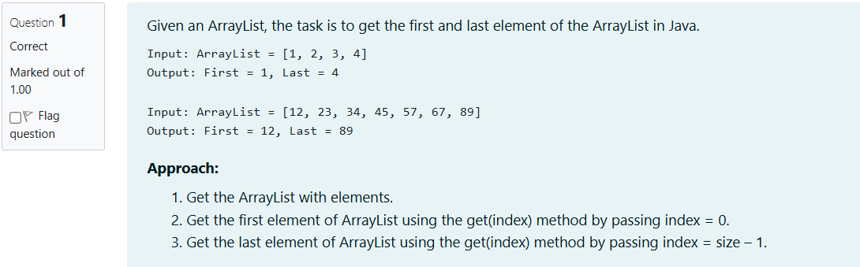

import java.util.ArrayList;

import java.util.Scanner;

public class Main {

public static void main(String[] args) {

Scanner scanner= new Scanner(System.in);

ArrayList<String> list = new ArrayList<>();

int n= scanner.nextInt();

scanner.nextLine();

for (int i = 0; i < n; i++) {

String element =scanner.nextLine();

list.add(element);

}

if (!list.isEmpty()) {

String firstElement= list.get(0);

String lastElement= list.get(list.size() - 1);

System.out.println("ArrayList: "+list);

System.out.println("First : "+ firstElement+", Last : "+lastElement);

} else {

System.out.println("The ArrayList is empty.");

}

scanner.close();}}

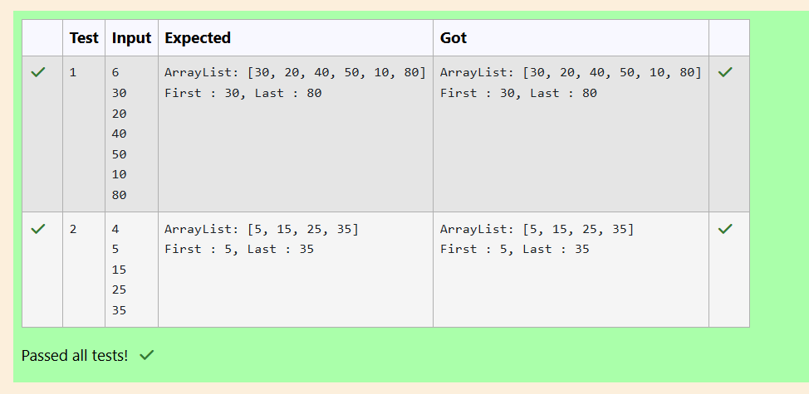

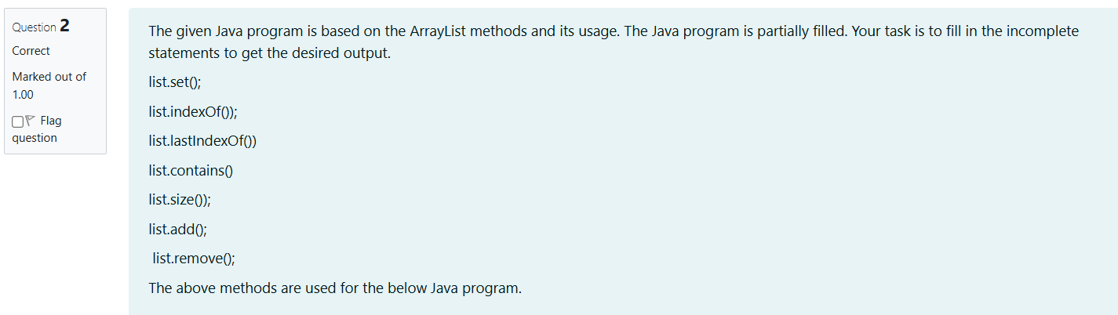

import java.util.ArrayList;

import java.util.Scanner;

public class Prog {

public static void main(String[] args) {

Scanner sc = new Scanner(System.in);

int n = sc.nextInt();

ArrayList<Integer> list = new ArrayList<Integer>();

for (int i = 0; i < n; i++) {

list.add(sc.nextInt());

}

System.out.println("ArrayList: " + list);

if (list.size() > 1) {

list.set(1, 100); // Replace element at index 1

}

System.out.println("Index of 100 = " + list.indexOf(100));

System.out.println("LastIndex of 100 = " + list.lastIndexOf(100));

System.out.println( list.contains(200)); // Output: false

System.out.println("Size Of ArrayList = " + list.size());

list.add(1, 500); // Insert 500 at index 1

if (list.size() > 3) {

list.remove(3); // Remove element at index 3

}

System.out.println("ArrayList: " + list);

sc.close();

}

}

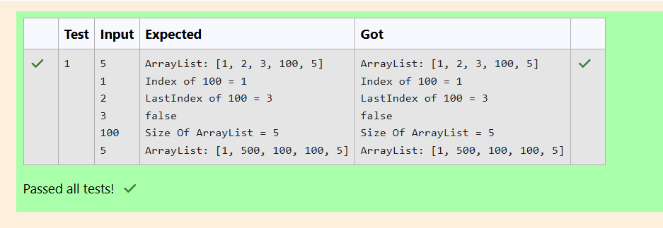

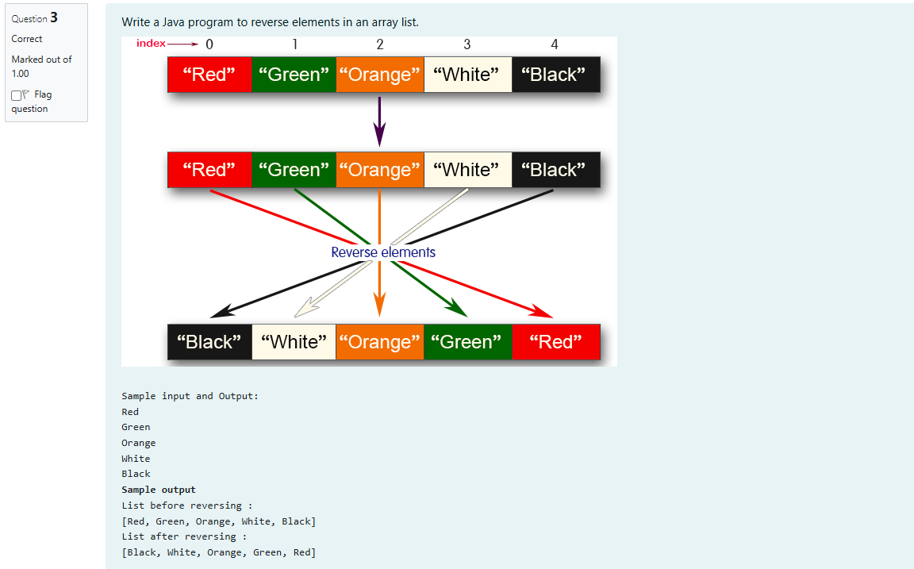

import java.util.ArrayList;

import java.util.Collections;

import java.util.Scanner;

public class Main {

public static void main(String[] args) {

Scanner scanner = new Scanner(System.in);

ArrayList<String> list = new ArrayList<>();

int n = scanner.nextInt();

scanner.nextLine();

for (int i = 0; i < n; i++) {

String element = scanner.nextLine();

list.add(element);

}

System.out.println("List before reversing :");

System.out.println(list);

Collections.reverse(list);

System.out.println("List after reversing :");

System.out.println(list);

scanner.close();

}

}

